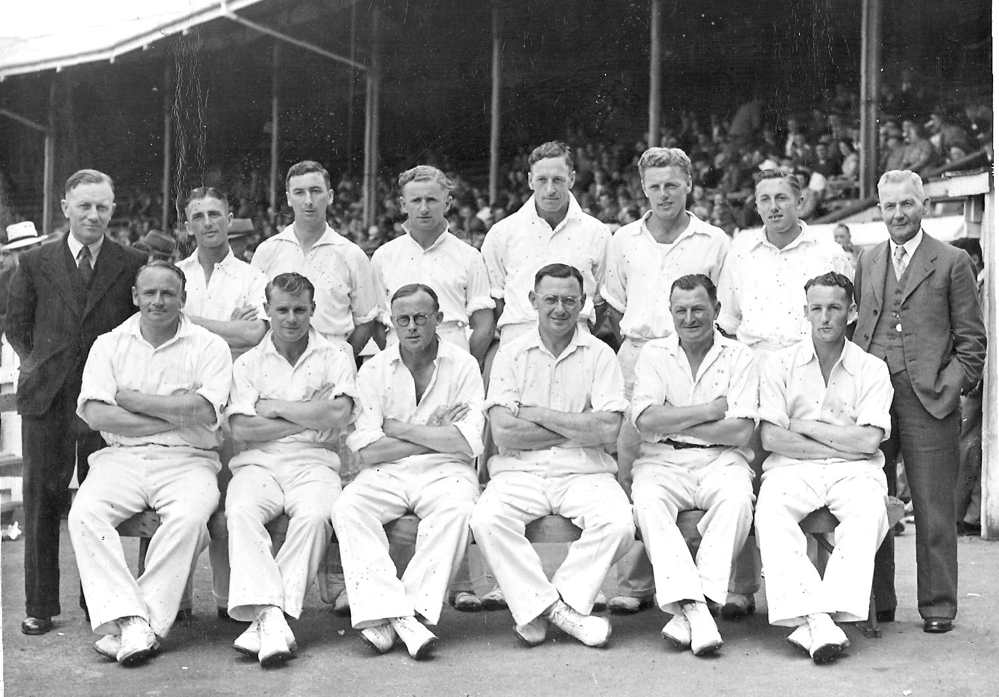

**Canterbury Representative Team 1946-47**

**Back row:** CG Crawford (manager), W Pollitt, AEL Britton, EC Carston, RH Scott, AT Burgess, PAT Small, RH North (manager)

**Front row:** TB Burtt, FB Smith, WMcD Anderson, IB Cromb, JH Parks, RC Shand